Computer Language Coding Concepts

Add
A related list’s system interface has an Add command.
The system member Add is part of the system interface of a related list and is displayed in a diagram as follows:

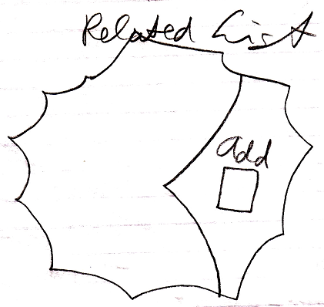

The Add command adds an item to the list. The Add command returns the related list item. The related list item may contain Nothing. Either way, the related list item can be used, even when it does not refer to any object yet. The related list item stores its position in the list, if that is what you are interested in.

The procedure around the Add command can be extended with extra functionality, as explained in the section Extending the System Interface.

See also: System Objects, Related List, Extending the System Interface

Author & Copyright: Jan-Joost van Zon Date: July 17, 2008 – July 24, 2009 Location: Oosterhout, The Netherlands Status: Finished

